**SCHOOL OF ELECTRICAL ENGINEERING AND COMPUTER SCIENCES**

**___EE-221: DIGITAL LOGIC DESIGN___**

**___________________________________________________**

**FINAL SEMESTER PROJECT REPORT**

**4-WAY SMART TRAFFIC LIGHT SYSTEM  
___________________________________________________**

|  |  |
| --- | --- |
|  |  |

**FACULTY MEMBER: SIR ARSHAD NAZIR**

**LAB ENGINEER: SIR MUGHEES AHMED**

**SUBMITTED BY:**

**FILZA UMAR (464340)**

**SYEDA MALEEKA ABBAS (466474)**

**SEMESTER: FALL 2024**

**DEDICATION:**

**We dedicate this project to our professors, lab instructors and university to give us the opportunity and guidance to work on such an interesting topic. We also thank our families for their constant encouragement and support, and our classmates for their helpful advice during the project.**

**_____________________________________________________________**

**ACKNOWLEDGEMENT:**

**We sincerely thank our professor Sir Dr Arshad Nazir and our lab engineer Sir Mughees Ahmed for guiding us throughout the project and helping us solve challenges along the way. We are also grateful to our classmates for their support and to the university for providing access to the tools and resources needed to complete this project.**

**ABSTRACT:**

This project presents the development of a smart traffic light system designed to optimize traffic flow using real-time vehicle detection. By integrating IR sensors, Timer 555 ICs, multiplexers, and D-flip flops, the system dynamically adjusts traffic signals based on current conditions. The implementation addresses challenges in sensor connectivity and circuit debugging, resulting in a reliable and efficient traffic management solution. This innovation has significant implications for improving urban mobility and reducing congestion at intersections.

**Table of Contents:**

**1. Introduction:** 5

**2. Design:** 6

**3. Hardware Implementation:** 9

**4. Project Applications:** 12

**5: Future Recommendations:** 12

**6.References / Bibliography:** 13

# **1. Introduction:**

**1.1 Overview of Project:**

The smart traffic light system aims to enhance traffic management by utilizing IR sensors to detect vehicle presence. The system dynamically adjusts the traffic light signals based on real-time traffic conditions, reducing congestion and improving safety at intersections.

**1.2 Block Diagram of Complete System:**

**1.3 Work Division:**

|  |  |
| --- | --- |
| **FILZA UMAR** | **MALEEKA ABBAS** |
| 1. Proteus Simulation | 1. K-map simplification |
| 1. State Diagram | 2. Hardware Implementation |
| 1. Hardware Implementation | 3. Debugging |

# **2. Design:**

**2.1 Problem Statement:**

Traffic congestion and accidents at intersections are significant issues in urban areas. This project addresses the need for an intelligent traffic control system that adapts to real-time traffic flow.

**2.2 State Diagram:**

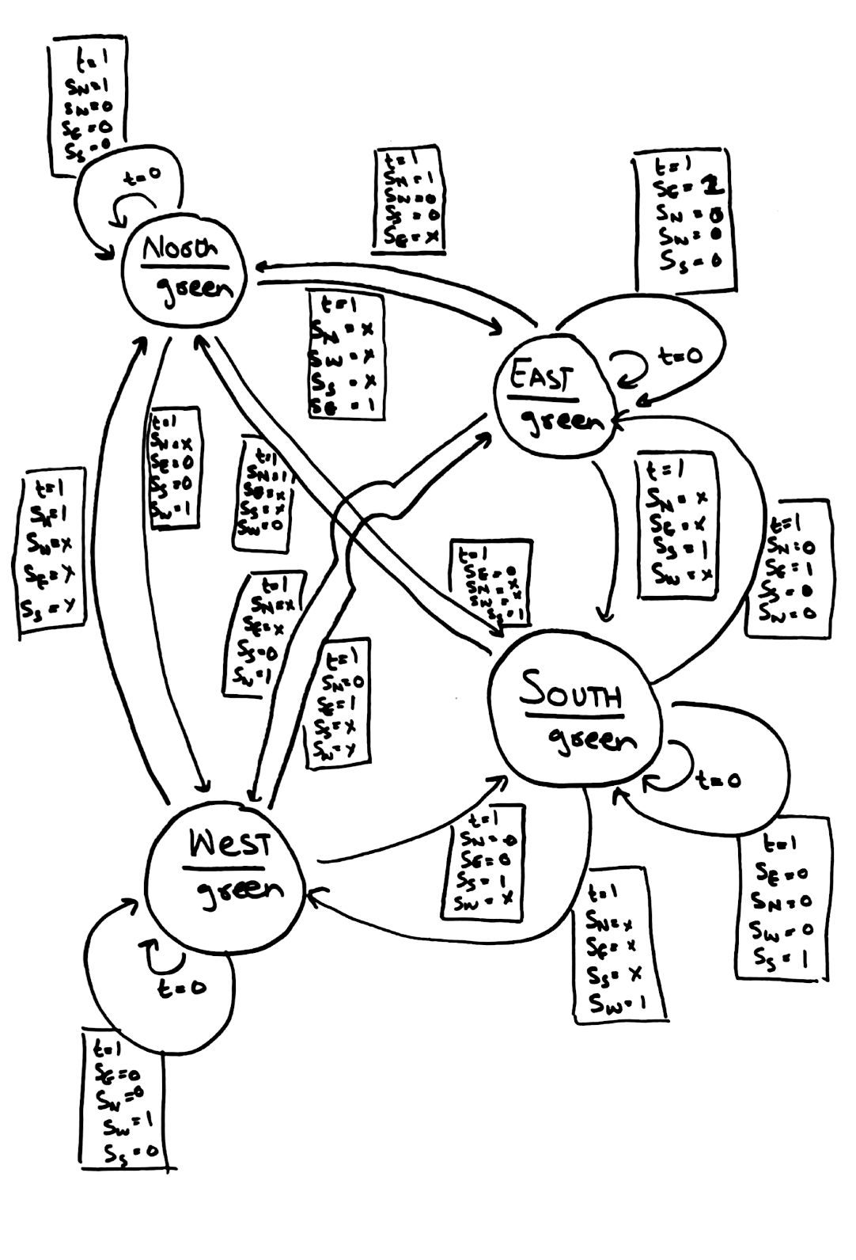

**KEY:**

|  |  |
| --- | --- |
| 00 | North |
| 01 | East |
| 10 | South |
| 11 | West |

Sn - North Sensor

Se - East Sensor

Ss - South Sensor

Sw - West Sensor

**2.3 State Table:**

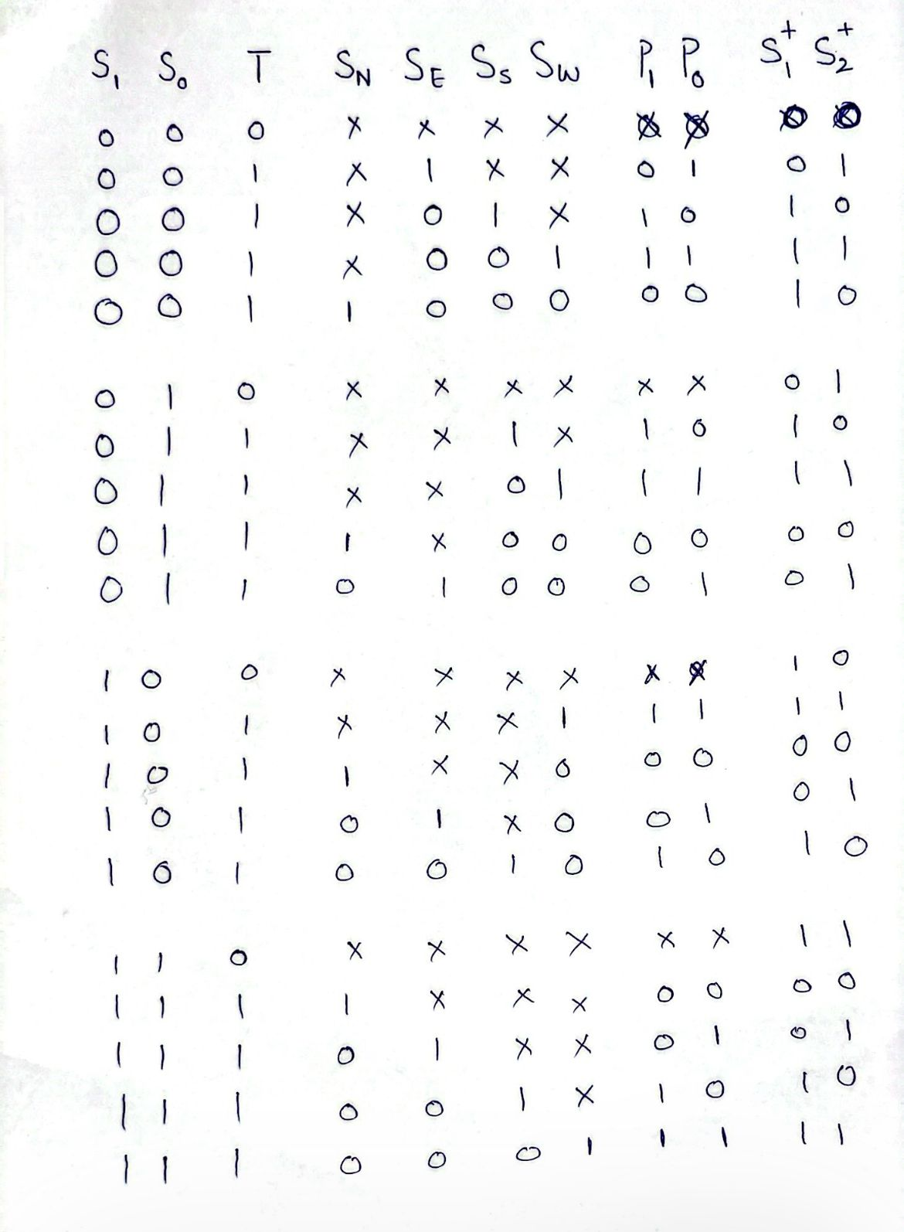

**2.4 Simplification of Functions / K-Maps & Equations (For priority encoder circuit design):**

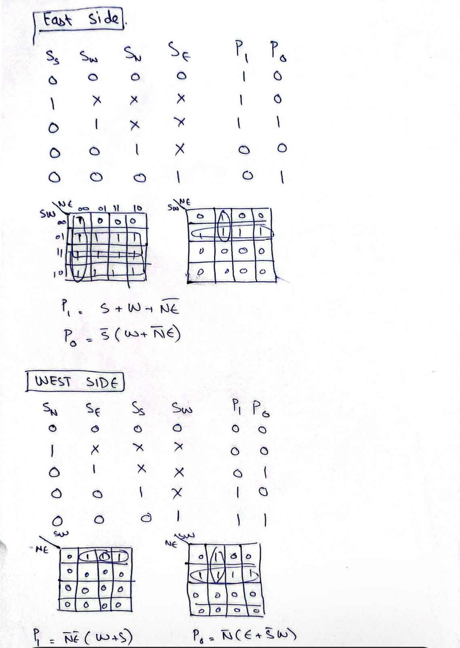

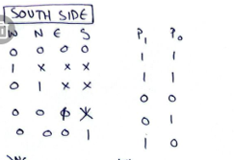

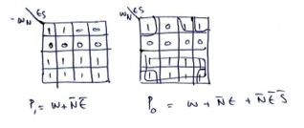

* When current state is east, highest priority, when time =1 is for South, then West, North, then lastly east itself and similarly the process goes for all other states as well.

**2.5 Output Combinational Circuit Simplifications:**

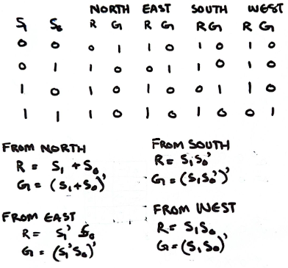

**2.5 Simulation:**

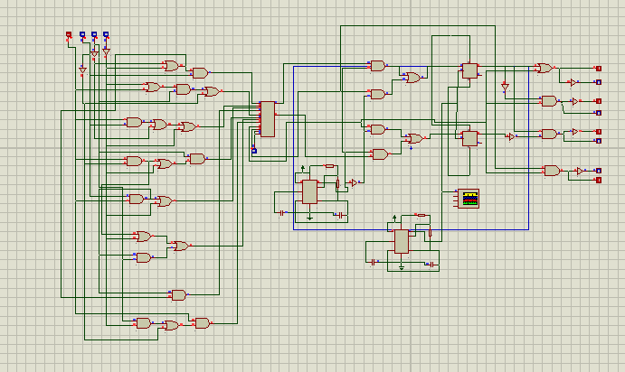

# **3. Hardware Implementation:**

**3.1 IC Pin Diagrams:**

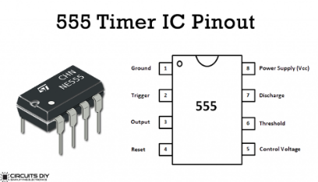

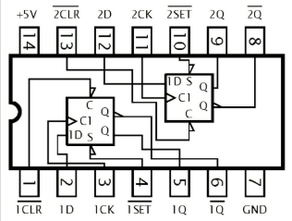

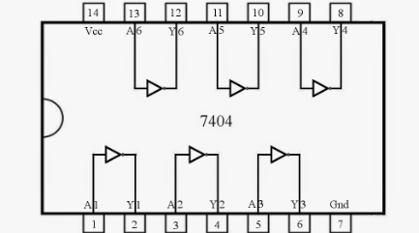

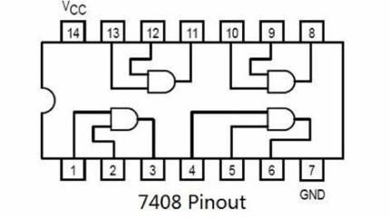

**3.2 Details of ICs Used**

* **Timer 555**: Used for timing control.
* **Multiplexer (MUX)**: For selecting the active traffic light based on inputs.
* **D-Flip Flops**: For state storage and control.
* **AND, OR, NOT Gate ICs:** For input and combinational circuits

**3.3 Details of Other Components Used**

* **IR Sensors**: To detect vehicle presence.
* **Resistors**: For current limiting.

**3.4 Hardware Issues / Results/ Observations**

During the hardware implementation of the smart traffic light system, we faced several challenges:

1. Sensor Connectivity: Initial wiring of the IR sensors led to inconsistent readings. After realigning and securing connections, the reliability of vehicle detection improved.
2. Debugging Challenges: We encountered logical errors that complicated signal flow. Using multimeters, we traced the circuit to identify and fix issues with voltage levels.
3. Flip-Flop Setup: Configuring the D-Flip Flops was tricky due to incorrect clock timing. Adjustments based on timing diagrams helped achieve the desired state transitions.
4. MUX Configuration: Integrating the multiplexer was challenging due to incorrect logic levels. Once we corrected the connections, the output matched the expected traffic light states.

**Results:**

After resolving these issues, the system functioned effectively, accurately detecting vehicles and optimizing traffic light signals.

# **4. Project Applications:**

**4.1 Digital Systems and Computers:**

The principles used in this project can be applied to various digital systems for efficient control and automation.

**4.2 Arithmetic Logic Units (ALUs):**

Understanding logic gates and flip-flops is fundamental for designing ALUs in computer architecture.

**4.3 Error Detection and Correction:**

The logic design can be adapted for error detection systems in data transmission.

**4.4 Digital Watches and Counters:**

Similar timing mechanisms can be used in digital watches and counters for accurate timekeeping.

**4.5 Embedded Systems:**

The project exemplifies the use of embedded systems in real-time applications.

# **5: Future Recommendations:**

**5.1 Incorporation of Multi-Digit Arithmetic:**

Future iterations could integrate multi-digit arithmetic for more complex traffic control algorithms.

**5.2 Error Detection & Correction:**

Implementing error detection mechanisms can improve the reliability of the system.

**5.3 BCD Greater than 9 and Showing Error:**

The system could be enhanced to handle BCD values greater than 9, with appropriate error signalling.

# **6.References / Bibliography:**

1. **Books:**
   * **"Digital Design" by M. Morris Mano and Michael D. Ciletti.**
     + A comprehensive guide to digital design principles and techniques, including flip-flops and multiplexers.
   * **"Fundamentals of Microcontrollers and Applications" by Ramesh S. Gaonkar.**
     + Covers microcontroller basics, interfacing, and applications in embedded systems.
2. **Research Papers:**
   * **"Smart Traffic Management System Using IoT" by S. S. Patil et al.**
     + Available on platforms like ResearchGate or IEEE Xplore.
   * **"An Intelligent Traffic Control System Based on Real-Time Traffic Data" by A. M. Alshahrani et al.**
     + Discusses real-time traffic management solutions.
3. **Datasheets:**
   * **555 Timer IC Datasheet:**
     + [NE555 Datasheet](https://www.ti.com/lit/ds/symlink/ne555.pdf)
   * **D-Flip Flop Datasheet:**
     + [74HC74 Datasheet](https://www.ti.com/lit/ds/symlink/sn74hc74.pdf)

4. **Sites for reference:**

<https://www.bing.com/ck/a?!&&p=f4e5dcd0f4a66d4fcf904061ba9b4fe33c4febde93937f6a920fba179b2f3de1JmltdHM9MTczNTYwMzIwMA&ptn=3&ver=2&hsh=4&fclid=06b4f69a-339d-6039-013f-e45932c7614f&psq=4+way+smart+traffic+light+system+dld&u=a1aHR0cHM6Ly9zdHVkeWxpYi5uZXQvZG9jLzI1OTg4NDg3LzR3YXktdHJhZmZpYy1maW5hbC1yZXBvcnQtLTEt&ntb=1>

<https://www.bing.com/ck/a?!&&p=0b0dce32eea301c261064766e6010ed45f114b9c5327b8c97535dc370a1ec3cbJmltdHM9MTczNTYwMzIwMA&ptn=3&ver=2&hsh=4&fclid=06b4f69a-339d-6039-013f-e45932c7614f&psq=4+way+smart+traffic+light+system+dld&u=a1aHR0cHM6Ly93d3cucmVzZWFyY2hnYXRlLm5ldC9wdWJsaWNhdGlvbi8zMDU2NzQ0MDhfU21hcnRfdHJhZmZpY19saWdodF9jb250cm9sX3N5c3RlbQ&ntb=1>